Feedback Form for Cell Products
Please fill in the fields neatly and check the corresponding boxes (* indicates required fields)
Customer Information
*Name | Helen | ＊E-mail | example@example.com
Address | (Not required to fill in)
*Complaint Requirements | Re-delivery Refund Other _
Supplier Company Name | (Please fill in the information if you know it; this field is not required.)
Cell Information
*Cell Name | 293 [HEK-293] | *Cat. No. | CL-0001
Lot | L890309061719 | *Delivery Date | 2026/05/29
*Storage Conditions | Directly resuscitate  Stored in a liquid nitrogen tank; storage duration: __________  Stored at-80°C; storage duration: __________
Cell Culture Medium Information
*Complete Culture Medium | MEM+10% FBS+1% Penicillin-Streptomycin | Preheat the culture medium | Yes No
*Culture Medium Brand | Procell complete culture medium; Cat. No.: CM-0001  Self-prepared culture medium：  Basic medium brand: Cat. No.:  Serum brand: Cat. No.:  Dissociation solution brand: Cat. No.:  Antibiotics brand: Cat. No.:
*Feedback Information
- Cell label:
(If you have the information shown in the picture, please provide it to us.)

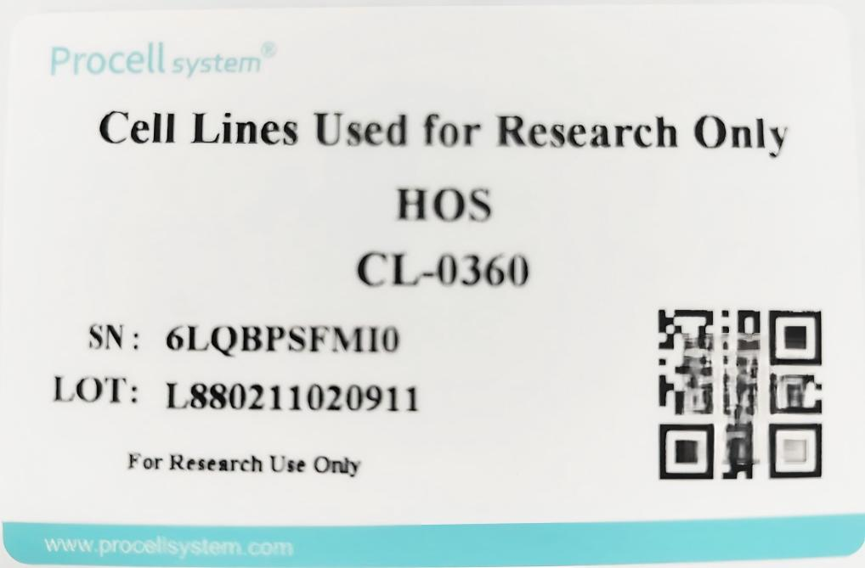

- Please describe the issue you encountered
(Brief description of the cell culture conditions from the time of cell receipt until culture issues arose, including any abnormalities observed during cultivation.)

- Cell State Records
  - The photos taken when the cells received.

  - Micrographs of cell recovery at 24 hours post-thawing

  - Micrographs of abnormal phenomena during cell recovery and culture processes

- Other comments or explanations regarding the situation

